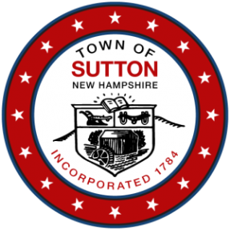
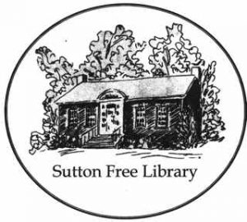
TOWN of SUTTON
SUTTON FREE LIBRARY
5 Corporation Hill Road
Sutton Mills, NH 03221
Board of Trustees
Agenda for Tuesday, June 8th, 2021

Date: Tuesday, June 8th, 2021
Time: 7:00 p.m.
Location: Zoom
Due to COVID19/Coronavirus Pandemic and in accordance with Governor Sununu's Emergency Order #12, pursuant to Executive Order 2020-04, this Board is authorized to meet electronically. The public has access to contemporaneously listen and participate in this meeting by going to zoom.us .
Click "join a meeting" in upper right-hand corner.
Enter the following meeting ID and password.
MEETING ID: 410-657-535
MEETING PASSWORD: SFLBOT
Audio conferencing participant will need to call: (415) 762-9988 or (646) 568-7788.
AND follow the verbal instructions.
Enter the meeting ID, 818538 Followed by the # key.

If there are any issues connecting please email:
suttonlibrarian@gmail.com

Agenda:

Call to Order
- Roll Call, Introduction of guests
- Public Comments
- Review of May 2021 meeting draft minutes
- Correspondence
Reports
- Financial/Treasurer’s Report
- Library Director Report
1. Reopening Plan
2. Museum Passes
- Building and Grounds Report

Old Business
- Evaluation Review/Website

New Business
Announcements
New Action Items
Adjournment

