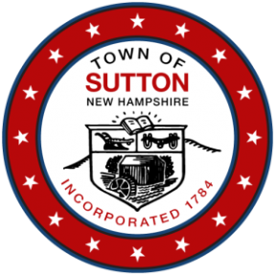
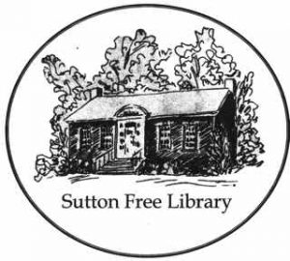
TOWN of SUTTON
SUTTON FREE LIBRARY
5 Corporation Hill Road
Sutton Mills, NH 03221
Board of Trustees
Agenda for Tuesday, February 15^{th,} 2022

Date: Tuesday, February 15th, 2022
Time: 7:00 p.m.
Location: Sutton Free Library
Governor Sununu's Emergency Order #12, pursuant to Executive Order 2020-04 has ended. This Board will be meeting in person at the Sutton Free Library. The public can listen and actively participate in this meeting by going to zoom.us .
Click "join a meeting" in upper right-hand corner.
Enter the following meeting ID and password.
MEETING ID: 410-657-535
MEETING PASSWORD: SFLBOT
Audio conferencing participant will need to call: (415) 762-9988 or (646) 568-7788.
AND follow the verbal instructions.
Enter the meeting ID, 818538 Followed by the # key.

If there are any issues connecting please email:
suttonlibrarian@gmail.com

Agenda:
Call to Order
- Roll Call, Introduction of guests
- Public Comments
- Sutton Planning Board
- Review of December 2021 and January meeting draft minutes
- Correspondence
Reports
- Financial/Treasurer’s Report
- Building and Grounds Report
- Library Director Report
Old Business a. MOU
New Business a. Library Director Office b. Meeting with Planning Board - March
Announcements
New Action Items
Adjournment

