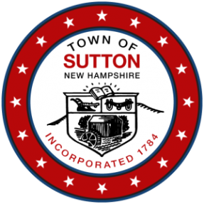
TOWN OF SUTTON
Pillsbury Memorial Hall
93 Main Street
Sutton Mills, NH 03221
ZONING BOARD OF ADJUSTMENT
Meeting Notice & Agenda
Wednesday April 17, 2024, at 7:00 p.m.

Call to Order
Roll Call
Public Hearings:
Case ZBA 2024-02 Concerning a request by Mark & Wendy Rosenthal, PO Box 388, 133 Corporation Hill Road, Map/Lot 6-265-381, North Sutton, NH 03260, for a Special Exception, as permitted by Article IV, Section B, 2, of the Sutton Zoning and Building Ordinance, to allow an Attached Accessory Dwelling Unit in the basement of their existing house.
Meeting Minutes: Review and approve minutes of the 3/20/24 ZBA meeting.
New Business: Election of Officers
Old Business: None Scheduled
Administrative: Next Meeting - as directed by the Chair.

