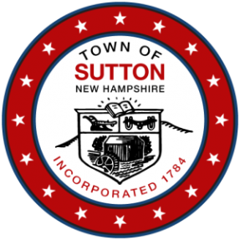

TOWN OF SUTTON
Pillsbury Memorial Hall
93 Main Street
Sutton /Mills, NH 03221
PLANNING BOARD MEETING
Notice and Agenda for Tuesday April 23, 2024, at 7:00 p.m.

CALL TO ORDER:

ROLL:

PUBLIC HEARINGS: None

ADMINISTRATIVE:

- Approval of Draft Meeting Minutes of the February 13, 2024, and the March 26, 2024, Planning Board Meetings.

OLD BUSINESS:

- Discussion of the Master Plan regarding future Planning Board direction.
- Case PB 2023-06 Verizon SPR – discuss condition of approval and alternate plan.

NEW BUSINESS:

ANY OTHER BUSINESS:

ADJOURNMENT:

